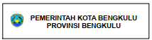
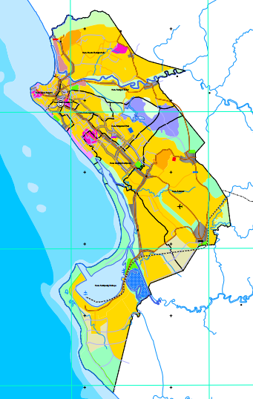
Study site
3º48’S
102º21’E
102º16’E
Kab. Benteng
Kab. Seluma
3º53’S

3º59’S

Figure 1. Study site in Kandang Mas village, Baai island, Bengkulu
(3º52’39,5”S 102º19’08,7”E)

