**Impact of Super Absorbent Polymer and Polyacrylamide on Water Holding Capacity on Ultisol, Lampung**

1\*Priyo Cahyono, 1Akhmad Syaifudin, 2Afandi, 2Winih Sekaringtyas Ramadhani

1Departement of Research and Development PT. Great Giant Pineapple, Lampung, Indonesia

2Department of Soil Science, Faculty of Agriculture, University of Lampung, Indonesia

\*priyo.cahyono@ggpc.co.id

**ABSTRACT**

Various methods of soil and water conservation in humid tropic have been carried out, one of which is by using chemicals to increase the stability of soil aggregates and water holding capacity. This experiment aims to use Polyacrylamide (PAM) and Super Absorbent Polymer (SAP) as materials to improve soil stability. The experiment was carried out in the Laboratory and Greenhouse R&D Dept. PT Great Giant Pineapple (PT GGP), Lampung. The treatment in laboratory experiments is by mixing the material into water in a ratio (g): water (ml), namely: 1 gram of material is dissolved in 100 ml of water or in a ratio of 1:100, then the next treatment is 1 gram of material in 200 ml or a ratio of 1:200, up to a ratio of 1:300 and 1:400. While the experiment in the Greenhouse is by mixing the SAP/PAM material into 100 grams of soil with a dose of 0 g (K), 4 g SAP (A) , 8.5 g (B) and 10 g (C). After the soil is mixed with the SAP material according to the dose, take 15 g and place it in a pot containing 1 kg of soil. Maintain the soil in field capacity. Based on the results of the study showed that SAP was a polymer that was able to increase the availability of water in the ultisol and sandy soils used in the experiment and was able to increase the water content of 18% compared to control (no treatment). PAM where this material is a polymer whose function is more dominant as an adhesive for aggregates instead of a water binder. Both of these materials can function as chemicals that can be used for chemical soil conservation.

**Keywords:** Super Absorbent Polymer, Polyacrylamide, Water Holding Capacity, Ultisol

**ABSTRAK**

Berbagai metode konservasi tanah dan air pada lahan tropika basah telah dilakukan, salah satunya adalah dengan menggunakan bahan kimia untuk meningkatkan kemantapan agregat tanah dan *water holding capacity.* Percobaan ini bertujuan untuk menggunakan bahan Polyacrylamide (PAM) dan Super Absorbent Polymer (SAP) sebagai bahan untuk memperbaiki kestabilan tanah. Percobaan dilakukan di Laboratorium dan Rumah Kaca R&D Dept. PT Great Giant Pineapple (PT GGP), Lampung. Adapun perlakuan pada percobaan laboratorium yaitu dengan mencampurkan bahan tersebut kedalam air dengan perbandingan (bahan (g) : air (ml), yaitu: 1 gram bahan dilarutkan dalam 100 ml air atau dengan perbandingan 1:100, kemudian perlakuan berikutnya 1 gram bahan dalam 200 ml atau perbandingan 1:200, hingga perbandingan 1:300 dan 1:400. Sedangkan percobaan di Rumah Kaca yaitu dengan mencampur bahan SAP/PAM kedalam 100 gram tanah dengan dosis masing-masing 0 g (K), 4 g SAP (A), 8,5 g (B) dan 10 g (C). Setelah tanah tercampur dengan bahan SAP sesuai dosis, ambil sebanyak 15 g dan tempatkan dalam pot yang berisi tanah 1 kg. Siram tanah dan dikondisikan pada kapasitas lapang (*field capacity*). Berdasarkan hasil penelitian menunjukkan bahwa Super Absorbent Polymer (SAP) adalah polymer yang mampu meningkatkan ketersediaan air pada tanah ultisol dan pasiran yang digunakan dalam percobaan dan mampu meningkatkan 18% kadar air dibandingkan dengan tanpa pemberian (kontrol). Namun berbeda dengan Polyacrylamide (PAM) dimana bahan ini merupakan polymer yang lebih dominan fungsinya sebagai bahan perekat agregat bukan pengikat air. Kedua bahan tersebut dapat berfungsi sebagai bahan kimia yang dapat digunakan untuk konservasi tanah secara kimiawi.

**Kata kunci:** Super Absorbent Polymer, Polyacrylamide, Kapasitas Menahan Air, Ultisol

**INTRODUCTION**

Indonesia is a country that has a humic tropic climate, which is characterized by high relative humidity (more than 90%), high rainfall (more than 1500 mm/year) and temperatures ranging from 180-380C. The high rainfall in the humic tropic, high soil erodibility on ultisol and high intensity of tillage on dry land can lead to high erosion rates. High soil erosion is exacerbated by the cultivation of monocultures on large scale, which cause the soil not have a canopy to withstand the blows of rainfall.

Various conservation methods have been carried out, including vegetative, mechanical and chemical methods. The use of soil amendments, including the use of polyacrylamide (PAM) and Super Absorbent Polymer (SAP) is one option in protecting the soil from being damaged by erosion. PAM is a water-soluble polymer grouped in the form of a compound formed by polymerization of acrylamide (Barvenik, 1994 in Green V.S., 2001). PAM is a polymer used for various purposes. The main use of PAM in agriculture is to stabilize soil and prevent erosion (Lentz and Sojka, 1994; Lentz et al., 1996; Trout et al., 1995 *in* Green, V.S., 2001). The form and type of PAM used in erosion control are large negatively charged (anionic) molecules (12-15 mega grams per mole) that are soluble in water. The chemical structure of polyacrylic acid has an ionizable -COOH functional group. These polymer chains can be cross-linked at -OH.

Polyacrylamide (PAM) can stabilize soil structure but cannot remediate soil that is already poorly structured. In areas with arid and mediterranean climates, PAM applications can be effectively used to improve and stabilize soil structure, increase soil infiltration, efficient use of irrigation water and reduce erosion rates (Lentz and Sojka, 1994; Lentz et al., 1996; Trout et al., 1995 *in* Green, V.S., 2001). PAM is a water-soluble polymer grouped in the form of a compound formed by polymerization of acrylamide (Barvenik, 1994 in Green, V.S., 2001).

Super Absorbent Polymer (SAP) from Chinafloc is a highly absorbent based water retainer that can increase water holding capacity for several years, reduce water loss, reduce irrigation frequency by up to 50% and reduce evaporation of water from the soil. Super absorbent polymer (SAP) is a material capable of absorbing up to 200 times the weight of liquid hydrogel material. The SAP material forms a gel structure and maintains the absorbed water content, despite pressure on it. SAP is made from acrylic acid monomer as raw material, plus cross-linking through suspension polymerization.

Super Absorbent polymers (SAP) is also a chemical conservation method that has been widely used as a water-retaining material in agriculture and horticulture. This is because when SAP is applied and mixed with soil it can bind water and nutrients, and is released slowly to plants in limited water conditions (Azzam, 1983; Huttermann et al., 1999; Yazdani et al., 2007 in Islam, M. R., et al., 2011).

The purpose of this experiment is to test SAP as a water retaining material and PAM as a water soluble polymer as a chemical method for improving soil physical properties.

**MATERIALS AND METHODS**

This research was conducted at PT. Great Giant Pineapple. The materials used are Super Absorbent Polymer (SAP) from China and Polyacrylamide (PAM). The soil used is ultisol soil and sandy soil. Experiments were carried out on a laboratory scale and greenhouse experiments. The experimental procedure is as follows: (1) Mixing PAM/SAP ingredients with water: prepare glass beakers for SAP and PAM materials. Each glass beaker added 1 g of SAP/PAM, Then water was added according to the treatment with the ratio of SAP/PAM ingredients, namely: (a) 1g: 100ml, (b) 1g: 200ml, (c) 1g: 300ml, and (d) 1g: 400ml. Then dissolved until blended within 1 minute. Next, the solution was weighed. (2) Application of SAP material with soil. The soil used in this study is 100 grams. This study was repeated 4 times for each treatment. The following are each treatment in this study (a) K (100 g + 0 g SAP), (b) A (100 g + 4 g SAP), (c) B (100 g + 8.5 SAP) and (d) C (100 g + 10 g SAP)

|  |  |  |  |
| --- | --- | --- | --- |
| IMG_1294 | IMG_1291 | IMG_1296 | IMG_1314 |

**Figure 1.** Measurement and mixing of materials with water

|  |  |  |  |
| --- | --- | --- | --- |
| Kontrol   1. K (100 g + 0 g SAP) | A 4 Gram  (b) A (100 g + 4 g SAP) | B  (c) B (100 g + 8.5 SAP) | C  (d) C (100 g + 10 g SAP) |

**Figure 2**. Mixing materials with soil

After the soil was mixed with the SAP material according to the treatment, then 15 g of the soil was taken and placed in a pot containing 1 kg of soil. Then, the soil is watered according to the conditions of field capacity.

|  |  |  |
| --- | --- | --- |
| DSCN3137 | DSCN3134 | DSCN31829 |

**Figure 3**. Sampling 15 g of soil and mixed with 1 kg of soil

**RESULTS AND DISCUSSION**

Observations show that the higher the concentration of PAM in the water, the more viscous the solution and shaped like glue **(**Figure 4). While SAP is a polymer which is a material capable of absorbing up to 200 times the weight of liquid hydrogel material. When the SAP material is mixed with water it will form a gel structure and maintain the water content it absorbs. SAP is made from acrylic acid monomer as raw material, plus cross-linking through suspension polymerization. SAP is a water retaining material that functions effectively to bind water, it is evident from the results of laboratory observations that it is clear that the SAP solution is in the form of thick gel bubbles.

|  |  |
| --- | --- |
| 12  **SAP PAM AIR** | 13  **SAP PAM AIR** |
| (1:200) | (1:300) |

**Figure 4.** Comparison of the results of dissolving SAP and PAM

From the results of research conducted by Busscher, et al. (2007) that the application of Polyacrylamide (PAM) with a dose of 120 mg Kg-1, can increase and improve the aggregation of loamy sand textured soils carried out in America.

|  |  |
| --- | --- |
| 145 | 100 |

**Figure 5**. PAM and SAP Solution Filtering

The soil that is applied to SAP will increase its field capacity, this proves that SAP is a water retaining material that is able to increase the water holding capacity of the ultisol soil used for the experiment (Figure 6). SAP can also reduce the rate of water losses on the ultisol soil used for the experiment (Figure 7). This is very beneficial in agriculture because the irrigation interval in the dry season can be longer, so it will be more cost efficient.

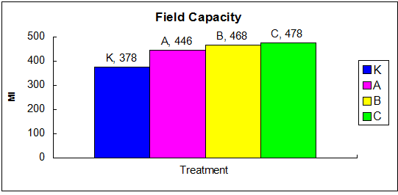

1. K (100 g + 0 g SAP), (b) A (100 g + 4 g SAP), (c) B (100 g + 8.5 SAP) and (d) C (100 g + 10 g SAP)

**Figure 6.** Field capacity of soil treated with SAP

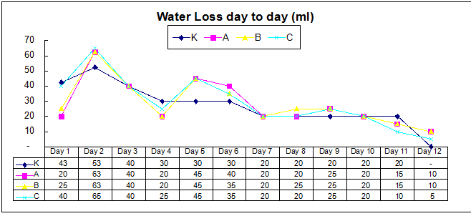

1. K (100 g + 0 g SAP), (b) A (100 g + 4 g SAP), (c) B (100 g + 8.5 SAP) and (d) C (100 g + 10 g SAP)

**Figure 7.** Water loss in various SAP treatments

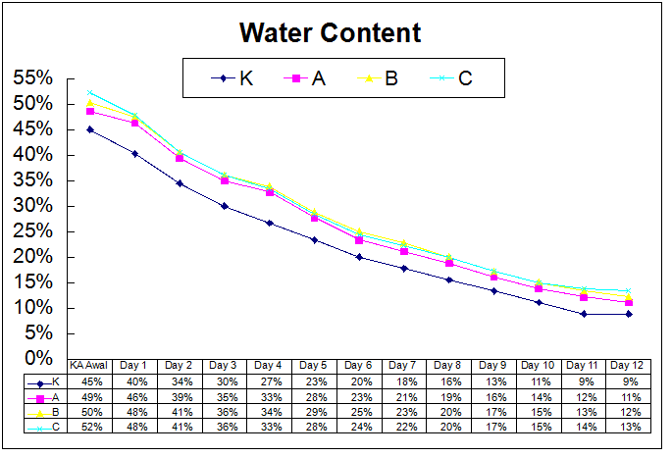

1. K (100 g + 0 g SAP), (b) A (100 g + 4 g SAP), (c) B (100 g + 8.5 SAP) and (d) C (100 g + 10 g SAP)

**Figure 8**. Trend of decreasing water content in various SAP treatments

Figure 8 shows that all SAP treatments, both at a dose of 4 g/100 g, a dose of 8.5 g/100 g, and 10 g/100g soil, had a higher water content than the control until the 12th day after treatment. This is in line with the research results that when SAP is applied and mixed with soil it can bind large amounts of water and nutrients and release slowly to plants under water-limited conditions (Azzam, 1983; Huttermann et al., 1999; Yazdani et al., 2007 in Islam, M. R., et al., 2011).

|  |  |
| --- | --- |
| DSC_0004  K (100 g + 0 g SAP) | DSC_0019  A (100 g + 4 g SAP) |
| DSC_0007  B (100 g + 8.5 SAP) | DSC_0014  C (100 g + 10 g SAP) |

**Figure 9**. Comparison of soil treated with SAP

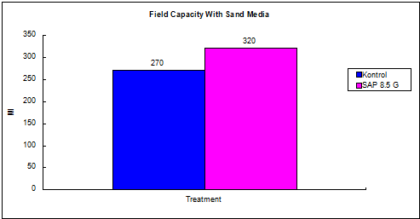

1. **18%**

**Figure 10.** Comparison of SAP treated soil with control on sandy soil

SAP also has a good effect on increasing the availability of water in sandy soils. It can be seen that SAP is able to increase 18% water content if compared of control (Figure 10).

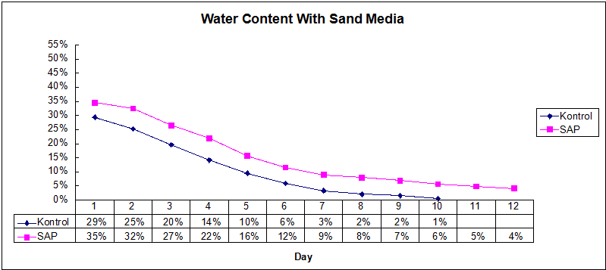

**Figure 11**. The rate of decrease in soil water content in the soil applied to SAP vs control

In sandy soil, the water content and rate of decrease in water content in the soil that was applied to SAP was also higher than the control (Figure 11). This is in line with the research results of Azzam, 1983; Huttermann et al., 1999; Yazdani et al., 2007 in Islam, M. R., et al., 2011 that when SAP is applied and mixed with soil it can bind large amounts of water and nutrients and release slowly to plants in limited water conditions (Azzam, 1983; Huttermann et al. al., 1999; Yazdani et al., 2007 in Islam, M. R., et al., 2011).

The level of water losses in the soil experiment that was applied to PAM did not show a significant difference compared to the control (Figure 12). This indicates that PAM is more of a material to protect and strengthen soil aggregates, not a water retaining material such as SAP. The rate of decrease in water content in the PAM treatment was also not different from that of the control (Figure 13).

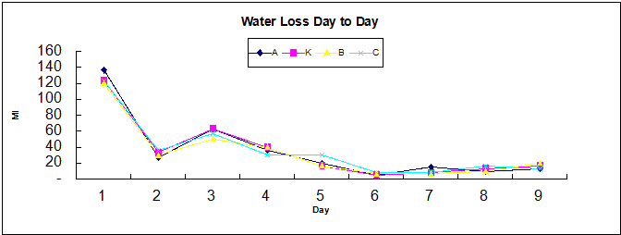

1. K (100 g + 0 g SAP), (b) A (100 g + 4 g SAP), (c) B (100 g + 8.5 SAP) and (d) C (100 g + 10 g SAP)

**Figure 12**. Water loss in various PAM applications

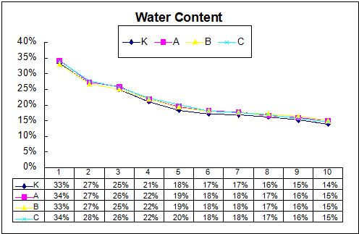

1. K (100 g + 0 g SAP), (b) A (100 g + 4 g SAP), (c) B (100 g + 8.5 SAP) and (d) C (100 g + 10 g SAP)

**Figure 15**. The rate of decrease in soil water content in the soil that was applied to SAP vs. control

**CONCLUSIONS**

Based on the results of the study showed that Super Absorbent Polymer (SAP) is a polymer that is able to increase the availability of water in ultisol soils and sandy soil used in the experiment and was able to increase the water content by 18% compared to the control. However, it is different from Polyacrylamide (PAM) where this material is a polymer whose function is more dominant as an aggregate adhesive instead of a water binder. Both of these materials can function as chemicals that can be used for chemical soil conservation.

**ACKNOWLEDGEMENTS**

The author would like to thank the staff and management of PT. Great Giant Pineapple, Central Lampung, who has helped this research both technically and the facilities provided to complete this research.

**REFERENCES**

Athena, Z., Afrianti, N. A., & Banuwa, I. S. (2020). Pengaruh Pemberian Polyacrylamide (PAM) terhadap Laju Erosi pada Bedengan yang Diukur dengan Metode Geodetik dan Beberapa Sifat Fisik Tanah di Tanah Ultisol. *Jurnal of Tropical Resources*, *02*(02).

Awad, Y. M., Blagodatskaya, E., Ok, Y. S., & Kuzyakov, Y. (2012). Effects of polyacrylamide, biopolymer, and biochar on decomposition of soil organic matter and plant residues as determined by 14C and enzyme activities. *European Journal of Soil Biology*, *48*, 1–10. <https://doi.org/10.1016/j.ejsobi.2011.09.005.>

Blodgett, A. M., Beattie, D. J., White, J. W., & Elliott, G. C. (2019). Hydrophilic Polymers and Wetting Agents Affect Absorption and Evaporative Water Loss. *HortScience*, *28*(6), 633–635. <https://doi.org/10.21273/hortsci.28.6.633>

Busscher, W. J., Novak, J. M., & Caesar-TonThat, T. C. (2007). Organic matter and polyacrylamide amendment of Norfolk loamy sand. *Soil and Tillage Research*, *93*(1), 171–178. <https://doi.org/10.1016/j.still.2006.03.023.>

Caesar-TonThat, T. C., Busscher, W. J., Novak, J. M., Gaskin, J. F., & Kim, Y. (2008). Effects of polyacrylamide and organic matter on microbes associated to soil aggregation of Norfolk loamy sand. *Applied Soil Ecology*, *40*(2), 240–249. <https://doi.org/10.1016/j.apsoil.2008.04.008.>

Cahn, M. (n.d.). A Guide to Using Polyacrylamide (PAM) Polymers for Control of Irrigation Run-off on the Central Coast.

Dou, C. Y., Li, F. H., & Wu, L. S. (2012). Soil Erosion as Affected by Polyacrylamide Application Under Simulated Furrow Irrigation with Saline Water. *Pedosphere*, *22*(5), 681–688. <https://doi.org/10.1016/S1002-0160(12)60053-8>.

Green, V. S., & Stott, D. E. (2001). <P046-Green.pdf>, 384–389. Retrieved from <https://www.five-elements.com.au/resources/Polyacrylamide>

A Review of the Use, Effectiveness and Cost of a Soil Erosion Control Amendment.pdf.

Inbar, A., Ben-Hur, M., Sternberg, M., & Lado, M. (2015). Using polyacrylamide to mitigate post-fire soil erosion. *Geoderma*, *239*, 107–114. <https://doi.org/10.1016/j.geoderma.2014.09.026>.

Islam, M. R., Xue, X., Mao, S., Zhao, X., Eneji, A. E., & Hu, Y. (2011). Superabsorbent polymers (SAP) enhance efficient and eco-friendly production of corn (Zea mays L.) in drought affected areas of northern China. *African Journal of Biotechnology*, *10*(24), 4887–4894. <https://doi.org/10.5897/AJB10.2152>.

Jiang, T., Teng, L., Wei, S., Deng, L., Luo, Z., Chen, Y., & Flanagan, D. C. (2010). Application of polyacrylamide to reduce phosphorus losses from a Chinese purple soil: A laboratory and field investigation. *Journal of Environmental Management*, *91*(7), 1437–1445. <https://doi.org/10.1016/j.jenvman.2010.02.006>.

Kang, J., McLaughlin, R. A., Amoozegar, A., Heitman, J. L., & Duckworth, O. W. (2015). Transport of dissolved polyacrylamide through a clay loam soil. *Geoderma*, *243*–*244*, 108–114. <https://doi.org/10.1016/j.geoderma.2014.12.022>.

Lentz, R. D. (2015). Polyacrylamide and biopolymer effects on flocculation, aggregate stability, and water seepage in a silt loam. *Geoderma*, *241*–*242*, 289–294. <https://doi.org/10.1016/j.geoderma.2014.11.019>.

Li, F. H., & Wang, A. P. (2016). Interaction effects of polyacrylamide application and slope gradient on potassium and nitrogen losses under simulated rainfall. *Catena*, *136*, 162–174. <https://doi.org/10.1016/j.catena.2015.05.008>.

Li, Y., Shao, M., & Horton, R. (2011). Effect of polyacrylamide applications on soil hydraulic characteristics and sediment yield of sloping land. *Procedia Environmental Sciences*, *11*(PART B), 763–773. <https://doi.org/10.1016/j.proenv.2011.12.118.>

Prats, S. A., Martins, M. A. dos S., Malvar, M. C., Ben-Hur, M., & Keizer, J. J. (2014). Polyacrylamide application versus forest residue mulching for reducing post-fire runoff and soil erosion. *Science of the Total Environment*, *468*–*469*, 464–474. <https://doi.org/10.1016/j.scitotenv.2013.08.066>.

Xu, S., Zhang, L., McLaughlin, N. B., Mi, J., Chen, Q., & Liu, J. (2015). Effect of synthetic and natural water absorbing soil amendment soil physical properties under potato production in a semi-arid region. *Soil and Tillage Research*, *148*, 31–39. <https://doi.org/10.1016/j.still.2014.10.002>.

Yakupoglu, T., Oztas, T., Kiray, F., & Demirkol, B. (2015). Effect of Some Polymers on Soil-water Losses and Sediment Size depending on Initial Aggregate Size under Sequential Simulated Rainfall. *Procedia Environmental Sciences*, *29*(Agri), 21. <https://doi.org/10.1016/j.proenv.2015.07.134>.