STATEMENT LETTER
The Originality of Manuscript

I hereby state that the manuscript entitled: Effect of Land Use Change on Soil Physico-Chemical Characteristics in Sungai Batang, East Part of Caldera Maninjau
with the author(s): Yulnafatmawita, Refdinal, Armansyah, Zainal A. Haris
is my (our) original work and has not been published overall or partly in a journal or a working paper or other types of publications. All the citations in the manuscript have been mentioned in the references according to the scientific of conduct, including other parties who have contributed on the content of the manuscript, except those related to writing style and expression.
I ensure that the statement mentioned above is true. Any kinds of misconducts on this statement is unacceptable academically and by law.

Padang, 15 December 2021
Name : Yulnafatmawita
Institution : Andalas University
Office Address : Agriculture Faculty, Andalas University, Kamus Unand Limau Manis, Padang
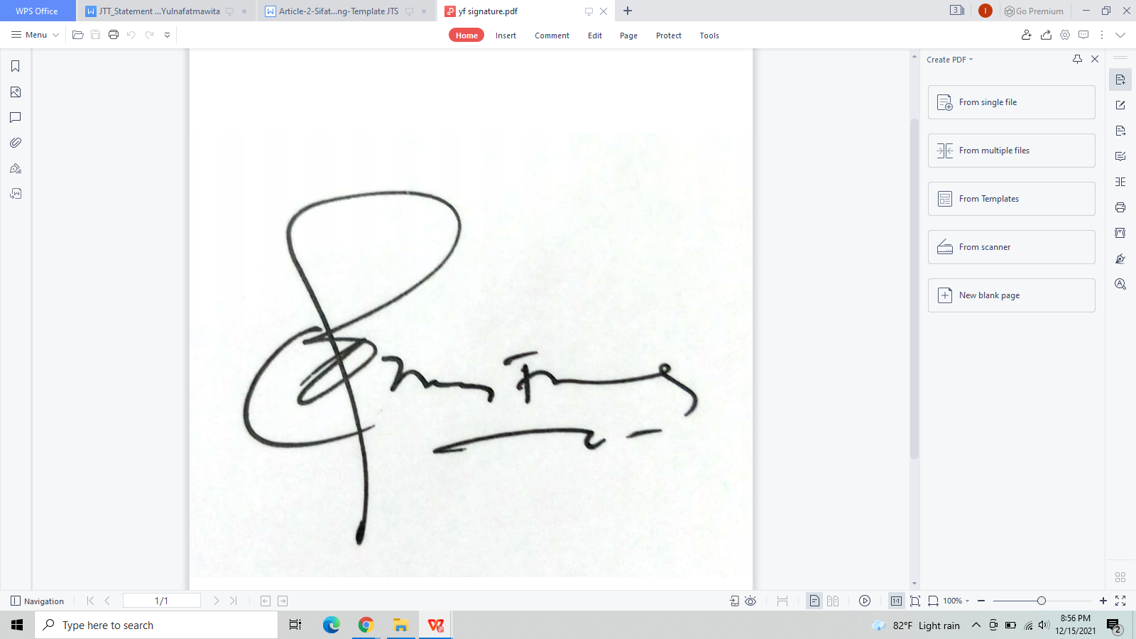
Signature :

