STATEMENT LETTER
The Originality of Manuscript

I hereby state that the manuscript entitled: Impact of Reforestation After Forest Fire on Infiltration and Other Soil Physical Properties
with the author(s): Iva Dewi Lestariningsih, Filza Roholesi Mewar, Akmaludin Dimas Anggara, Sarifudin Lathif, Ghozian Putra Sukbara, Sativandi Riza, Kurniawan Sigit Wicaksono, is our original work and has not been published overall or partly in a journal or a working paper or other types of publications. All the citations in the manuscript have been mentioned in the references according to the scientific of conduct, including other parties who have contributed on the content of the manuscript, except those related to writing style and expression.
I ensure that the statement mentioned above is true. Any kinds of misconducts on this statement is unacceptable academically and by law.

Pingtung, 14 February 2023
Name : Iva Dewi Lestariningsih
Institution : Brawijaya University
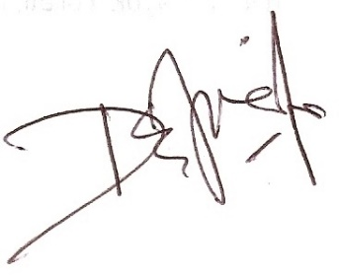
Office Address : Jl. Veteran Malang, Jawa Timur, Indonesia 65145

Signature :

