**STATEMENT LETTER**

**The Originality of Manuscript**

I hereby state that the manuscript entitled: **Assessment of Andisol characteristics for the development of potato plants in Pangalengan**

with the author(s): Ganjar Herdiansyah, Mahfud Arifin, Abraham Suriadikusumah, Aktavia Herawati

is my (our) original work and has not been published overall or partly in a journal or a working paper or other types of publications. All the citations in the manuscript have been mentioned in the references according to the scientific of conduct, including other parties who have contributed on the content of the manuscript, except those related to writing style and expression.

I ensure that the statement mentioned above is true. Any kinds of misconducts on this statement is unacceptable academically and by law.

Surakarta, Novemver 6, 2023

Name : Ganjar Herdiansyah

Institution : Universitas Sebelas Maret

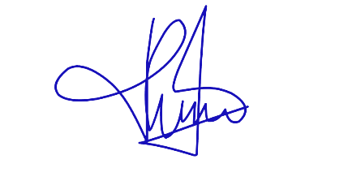Office Address : Surakarta

Signature :